MIE1624 — Canada AI Competitiveness Strategy
Final Report — Expected Results, Strategic Impact, and Conclusion

5. Expected Results and Strategic Impact

5.1 Canada's Competitive Starting Point
At the modelled baseline (2026Q1), Canada holds rank 5 of 13 benchmarked economies, with a composite AI competitiveness score of 32.86 out of 100. That position already overstates Canada's commercial and innovation conversion strength: the score is propped up by a perfect Government Strategy rating (100.0) and a strong Operating Environment (69.8), while the KPIs that reflect productive output tell a materially weaker story. The Tortoise Commercial Score registers 14.88, AI Investment Activity stands at 3.16, and Domestic AI Adoption reaches only 8.0 — all well below peer-cluster levels. Talent metrics are mixed: Canada records a comparatively high AI Hiring Rate YoY Ratio (73.73) but a much weaker Tortoise Talent Score (31.28), indicating strong near-term hiring activity that has not yet translated into retained senior capability or dense talent ecosystems. The Tortoise Development Score (25.78) and AI Patent Grants per 100k (0.83) signal a persistent gap between research production and commercial application.
Critically, the rank trajectory analysis shows that without intervention, Canada is not holding its position — it drifts from rank 5 to rank 6 by the second half of 2027, as peer economies incrementally accumulate innovation and commercial output at faster rates. This passive deterioration is the strategic starting condition against which the three recommendations must be evaluated.
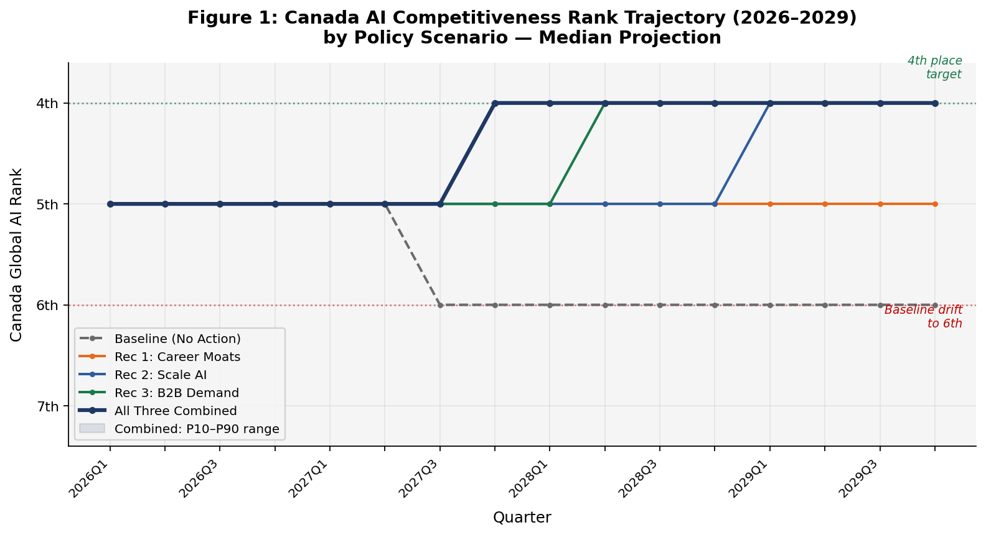
[Table 1: Canada Baseline KPI Scores vs. Peer Cluster | Figure A: Canada Rank Trajectory — Baseline vs. All Scenarios | Figure B: Canada Composite Score Trajectory 2026Q1–2029Q4]

5.2 Projected KPI Improvements by Recommendation
Each recommendation is projected to move a distinct cluster of KPIs. The effects are shown here on a stand-alone basis — that is, each recommendation is evaluated independently against the same Canada baseline. Because the three recommendations share several downstream KPIs, these stand-alone projections should not be added together; the combined scenario is modelled separately and discussed in Section 5.3.

Recommendation 1 — Build Career Moats for Talent (R1)
R1 targets Canada's talent retention and acquisition pipeline through an elite equity tax exemption, a salary-matching credit, and an AI Elite fast-track immigration stream. Its projected impacts are concentrated in the Talent sub-pillar. At the 2029Q4 horizon the stand-alone scenario projects a composite score of 33.87 (up from 32.86 at baseline), with Canada retaining rank 5 rather than slipping to 6. The gains are realised progressively, with meaningful score movement beginning around 2027Q2 as immigration and retention mechanisms reach operational maturity.
The KPIs that move most strongly under R1 are: Tortoise Talent Score (+4.66 points relative to baseline at quarter 16), AI Hiring Rate YoY Ratio (+3.73), Net Migration Flow of AI Skills (+3.57), AI Job Postings as a share of Total (+2.76), AI Talent Concentration (+2.08), and Relative AI Skill Penetration (+2.06). A secondary spillover to Tortoise Commercial Score (+0.83) and Tortoise Research Score (+0.80) is also projected, reflecting the downstream effect of retained senior talent on applied research and early-stage commercialization. R1 does not materially shift commercial output KPIs in the near term — its primary value is structural: converting Canada's existing talent acquisition activity into durable retention.

Recommendation 2 — Build the Conditions to Scale AI in Canada (R2)
R2 addresses the commercialization gap through a compute utilization subsidy, a federal procurement and pilot-to-contract conversion program, and a growth-stage co-investment vehicle. At quarter 16, the stand-alone scenario projects Canada's composite score at 34.42 (+1.55 vs. baseline), with Canada rising from rank 5/6 to rank 4. R2 moves commercial KPIs with the largest estimated projection gains of any single recommendation: Tortoise Commercial Score improves by 8.50 points, AI Investment Activity by 6.17, AI Job Postings by 4.13, AI Adoption by 2.12, and Tortoise Development Score by 0.63. The rank lift to 4th place is achieved by 2028Q4 in the median projection, consistent with the 12–18 month implementation and ramp-up lag built into the procurement and co-investment mechanisms.
R2's commercial KPI concentration means it directly addresses Canada's most structurally lagging pillar — Investment / Commercial Ecosystem — which currently sits at 29.6 on the composite weight basis, far below the Investment pillar scores of South Korea (26.1), Singapore (27.0), or the United States (83.8). Even in the stand-alone scenario, R2 closes more of Canada's rank gap than any single recommendation from a score perspective.

Recommendation 3 — Stimulate B2B Demand via Adoption Credits (R3)
R3 targets the demand side of the commercialization gap through a refundable first-customer AI adoption tax credit, eligibility rules that favour Canadian-owned IP and scale-ups, and an 18-month conversion mandate with clawback provisions. At quarter 16, the stand-alone scenario projects a composite score of 34.36 (+1.49 vs. baseline) and a rank of 4. The KPIs with the strongest projected movement under R3 are AI Adoption (+5.72 points), Tortoise Commercial Score (+7.63), and AI Investment Activity (+4.88). Notably, R3 is the only recommendation in the analysis that materially improves AI Patent Grants per 100k (+0.63), reflecting the IP eligibility rules creating a pathway from adoption-phase deployment to applied innovation output. The conversion mandate clause also moves Tortoise Development Score by +0.63.
R3 begins to produce score improvements from mid-2026 onward in the median projection, earlier than R2, because first-customer adoption credits are faster to operationalise than multi-stage procurement and capital formation pipelines.
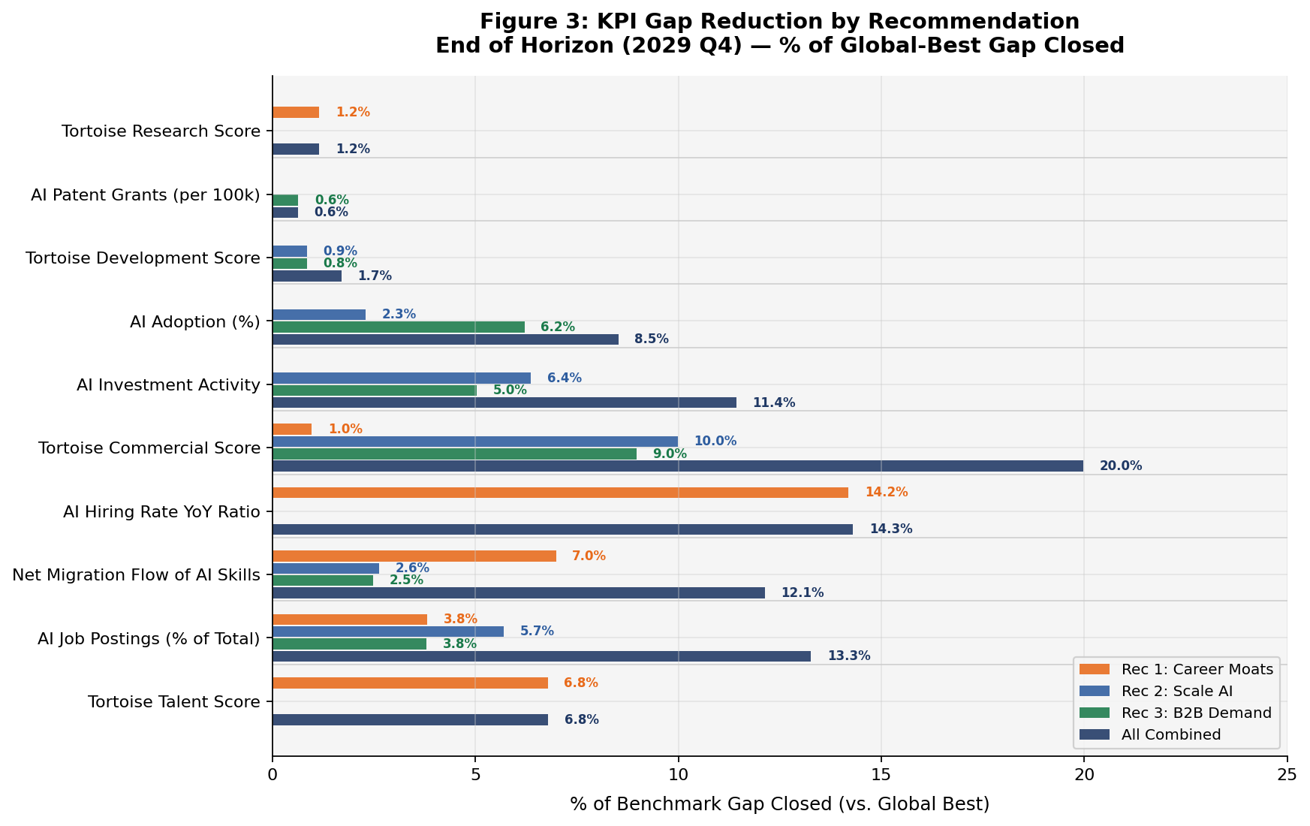
[Figure C: KPI Gap Reduction by Recommendation — Stand-Alone Comparison | Figure D: AI Adoption Trajectory — Baseline vs. R3 Scenario | Figure E: Tortoise Commercial Score — Baseline vs. R2, R3, All Recommendations | Table 2: Stand-Alone KPI Impact Summary by Recommendation at 2029Q4]
Recommendation | Composite Score (2029Q4) | Rank (2029Q4) | Score Delta vs. Baseline | Rank Delta
Baseline (no action) | 32.86 | 6 | — | −1
R1 only — Talent Moats | 33.87 | 5 | +1.01 | +1 (holds)
R2 only — Scale Conditions | 34.42 | 4 | +1.55 | +2
R3 only — Adoption Credits | 34.36 | 4 | +1.49 | +2
All 3 Recommendations | 36.93 | 4 | +4.07 | +2

5.3 Composite Score and Rank Trajectory — Combined Scenario
When all three recommendations are implemented together, the combined all-recommendations scenario projects Canada's composite score reaching 36.93 at 2029Q4 — a gain of 4.07 points above the frozen baseline and 4.07 points above where Canada began. Canada's rank is projected to improve to 4th place (from 6th under the baseline drift), moving Canada above the United Kingdom in the peer cluster. The 10th-to-90th percentile band at the end of the projection horizon spans 36.74 to 37.13, indicating a reasonably tight range around the central estimate.
The combined score of 36.93 is meaningfully above the sum-of-parts implied by individual scenarios, which reflects the structural interaction effects between the three recommendations: talent retention (R1) provides the human capital base that makes scale-up programs (R2) more productive, and domestic demand creation (R3) validates the commercial pipeline that co-investment vehicles (R2) are intended to fund. This interaction logic is encoded in the simulation's quarterly state-transition mechanics, not in a simple additive projection.
Worth noting is that the all-recommendations scenario does not lift Canada to rank 3 (currently held by South Korea, at 37.78 baseline). South Korea's lead is grounded in structural Development output — particularly AI Patent Grants and Development Score (86.35) — that three policy levers targeting talent conversion, commercialization, and domestic demand cannot replicate within a four-year window. The honest consulting position is that rank 4 with a materially stronger KPI profile is the achievable near-horizon target. Rank 3 is a plausible medium-to-long-run ambition, contingent on sustained policy execution beyond the current implementation horizon.
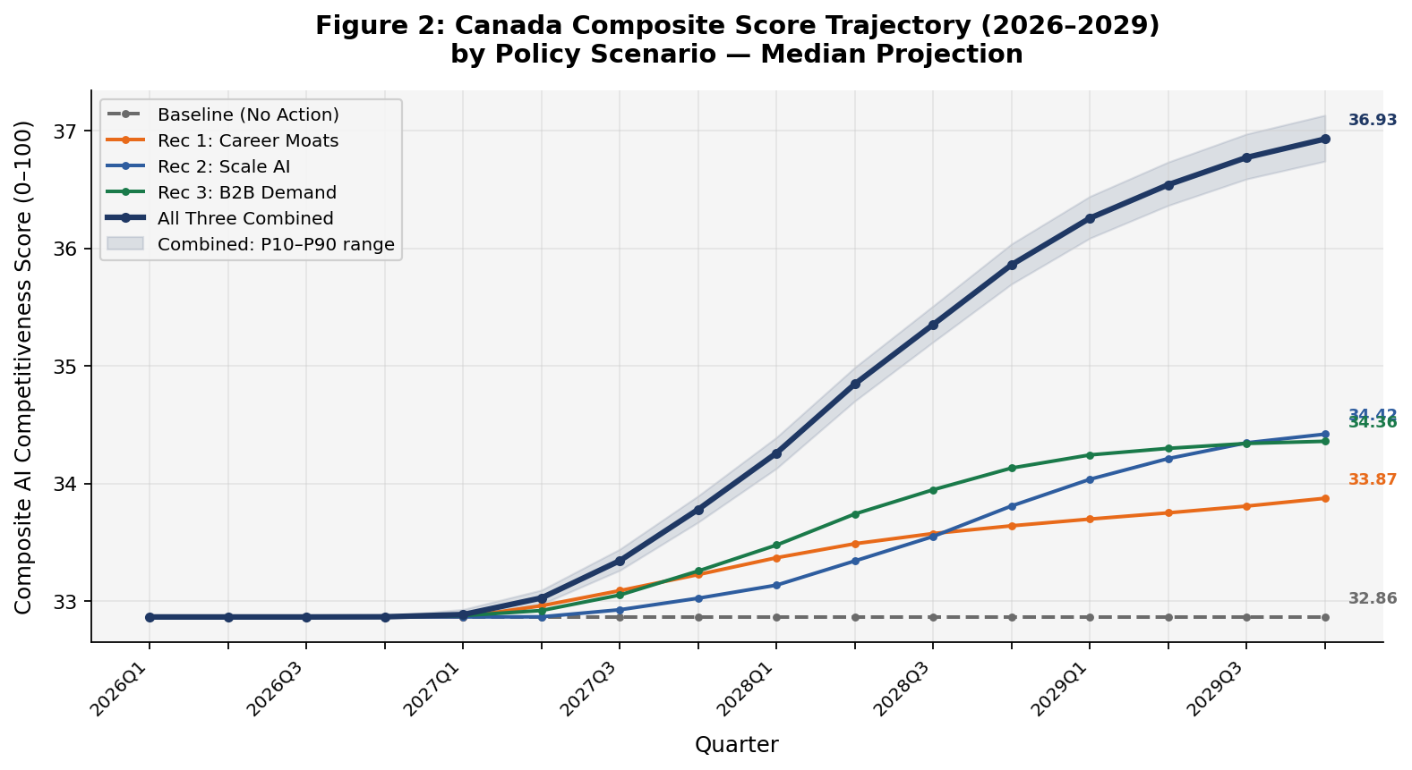
[Figure A: Canada Rank Trajectory — Baseline, Individual Scenarios, All Recommendations | Figure F: Composite Score Trajectory with 10th–90th Percentile Band | Figure G: Scenario Comparison — Score Waterfall at 2029Q4]

5.4 Operational Success Indicators
The modelled outcome targets translate into observable operational milestones that policymakers and program administrators can track within the four-year window:
- Talent: AI Hiring Rate YoY Ratio sustained above 70, net migration flow of AI talent turning materially positive, and attrition rates among senior AI personnel at priority-sector firms declining. A target of 75% attrition retention among supported firms has been used as an internal success proxy for R1.
- Commercialization pipeline: Over 50% of subsidized pilots converting to paid commercial contracts under the federal procurement program; growth-stage AI firms showing measurable scale-up in investment rounds within 24 months of co-investment support.
- Demand activation: Credit-subsidized AI deployments converting to multi-year commercial contracts at a rate exceeding 50%; pre-launch procurement commitments secured for at least 25–35% of AnchorAdopter program registry participants.
- Composite score signal: Canada's Tortoise Commercial Score crossing 20 out of 100 by mid-horizon (2028) would represent a meaningful structural shift from the current 14.88 and confirm that the commercialization pipeline is activating.
- 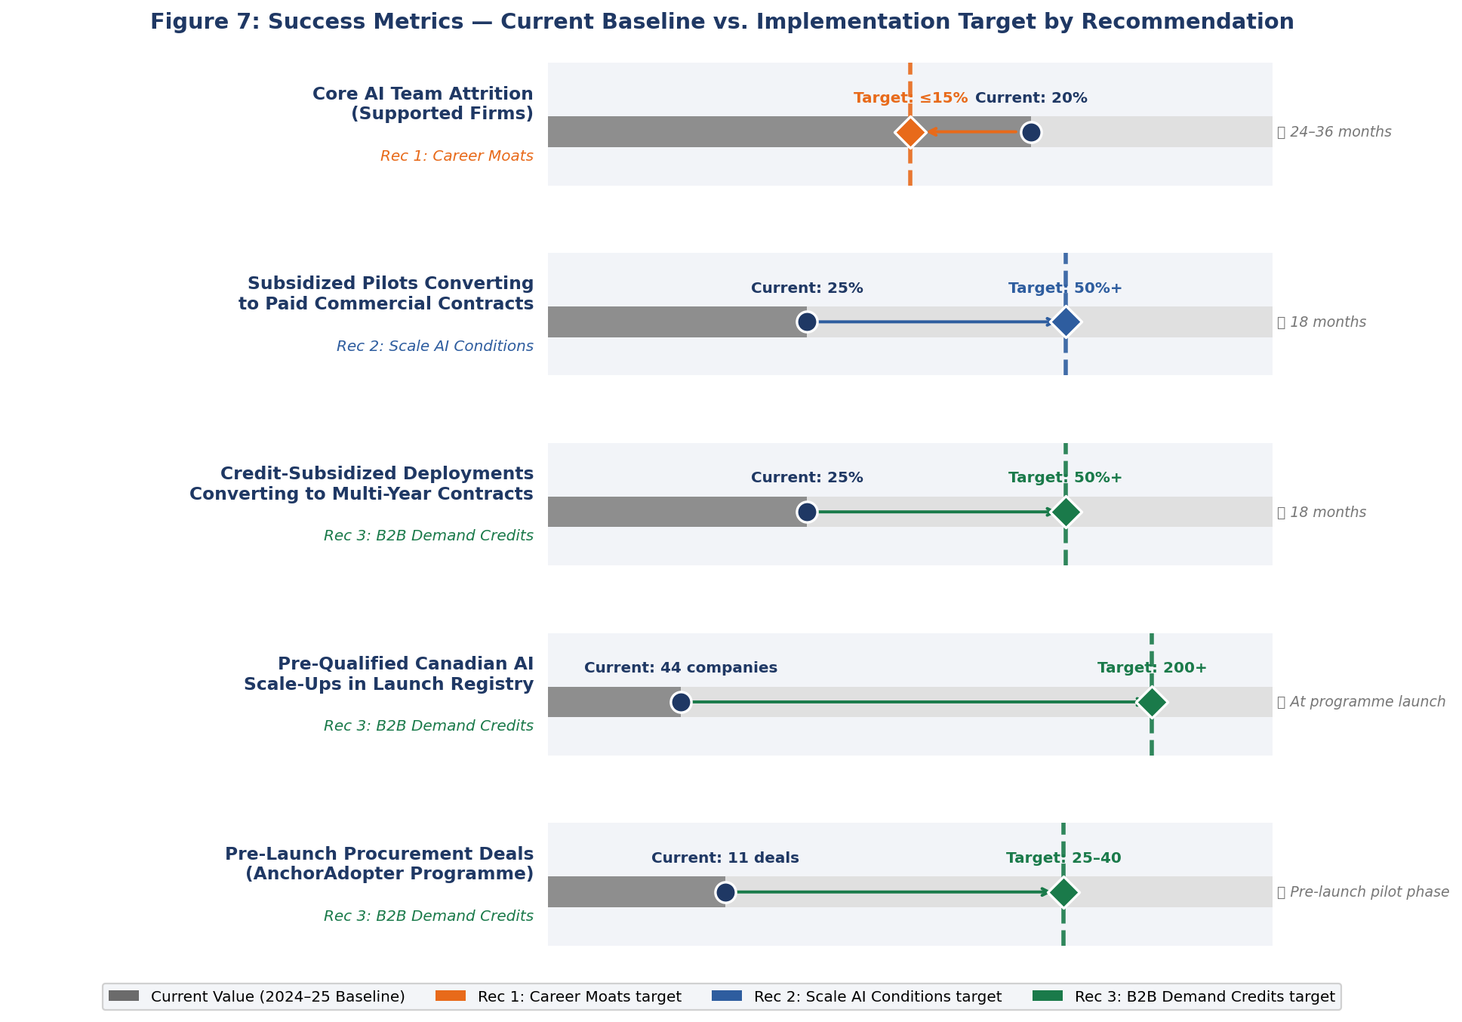
[Figure H: Success Metric Progress Toward Target — R1, R2, R3 | Table 3: Key Operational Milestones and Tracking Metrics by Recommendation]

6. Strategic Interpretation
The projected results confirm the central diagnostic of this analysis: Canada's AI competitiveness deficit is not primarily a policy-design or research-investment problem. Canada already scores at the maximum on Government Strategy and near-maximum on Operating Environment. Its academic research base is real — Tortoise Research Score at 30.67 and strong citation and publication metrics — and its talent hiring pipeline is active. The root problem is conversion: Canada consistently fails to translate policy strength and research output into retained senior talent, scaled commercial firms, and deep domestic market demand. The KPI profile tells this story precisely:
- Government Strategy and policy framework: 100.0 — fully built.
- Research and academic pipeline: active, but below leading peers.
- Talent hiring pipeline: running, but leaking senior value southward (attrition).
- Commercialization and scale-up: deeply weak — Commercial Score 14.88, Investment Activity 3.16.
- Domestic demand and adoption: critically underdeveloped — AI Adoption 8.0%.
The three recommendations are designed precisely to intervene at the points of conversion failure, not at the points of existing strength. R1 closes the retention-to-deployment gap in talent — converting hired talent into anchored, producing contributors rather than allowing them to exit. R2 closes the research-to-revenue gap in the commercial pipeline — providing the procurement, compute, and capital infrastructure that allows AI firms to move from demonstration to scaled deployment. R3 closes the supply-to-demand gap in adoption — creating the economic incentive for domestic buyers to become the first, proof-of-concept customers that Canadian AI firms need to validate market fit.
This sequencing matters strategically. Without demand-side activation (R3), R2's commercialization pipeline has insufficient market pull to validate the firms it funds. Without retained talent (R1), R2's scale-up infrastructure lacks the senior engineering and leadership capacity to execute. The recommendations are mutually reinforcing and most effective as a coordinated package, which is precisely why the all-recommendations scenario outperforms the sum-of-individual-scenario improvements.
The rank outcome — moving from a deteriorating 5th/6th to a stable 4th — understates the strategic significance of the KPI shifts. A composite score of 36.93 in 2029Q4 vs. 32.86 at baseline represents not just a rank move but a qualitatively different competitiveness position: a Canada where commercially deployed AI is measurably more prevalent, where first-buyer mechanisms reduce the valley-of-death attrition rate for domestic AI firms, and where senior AI talent has a credible economic case to remain and build in Canada rather than relocate for equity and compensation parity.
Importantly, the results are grounded in realistic policy mechanisms, not in structural changes that require multi-decade state-level investment. Canada does not need to match the United States on infrastructure spend or China on state-directed industrial policy to improve meaningfully within its peer cluster. The improvements modelled are achievable through targeted federal policy execution within a standard budget envelope, directed at the conversion bottlenecks that analysis has identified.
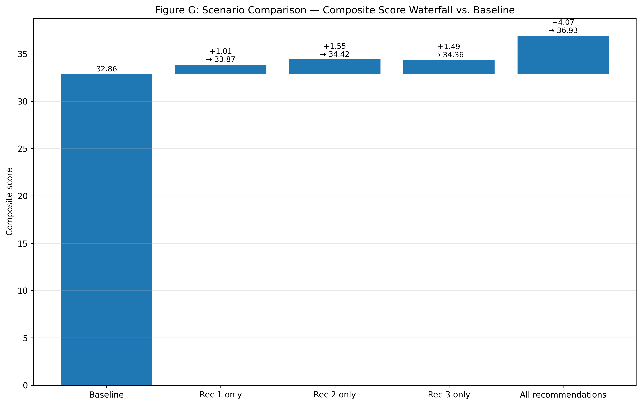
[Figure G: Scenario Comparison — Composite Score Waterfall vs. Baseline | Figure I: Pillar Score Comparison — Canada Baseline vs. All-Recommendations at 2029Q4 | Figure A: Canada Rank Trajectory — All Scenarios]

7. Conclusion
Canada enters 2026 with genuine AI competitiveness assets — strong government strategy, a functioning talent acquisition pipeline, credible academic research, and robust operating institutions — but with a structural inability to convert those assets into the retained talent, scaled firms, and domestic adoption that define a high-output AI economy. Without deliberate policy intervention, the analysis projects that Canada loses ground within its peer cluster, slipping from 5th to 6th rank as competitors compound commercial and development activity at higher rates.
The three recommended policy levers — Build Career Moats for Talent, Build the Conditions to Scale AI in Canada, and Stimulate B2B Demand via Adoption Credits — are projected to reverse this trajectory. Implemented together, they are expected to lift Canada's composite AI competitiveness score from 32.86 to 36.93 by 2029Q4, a gain of 4.07 points, and recover Canada's position to rank 4 within the benchmarked country set. Each recommendation addresses a distinct conversion failure point, and the three function as a coherent strategic package rather than independent interventions.
The commercial ecosystem is expected to see the most material transformation: the Tortoise Commercial Score, AI Investment Activity, and AI Adoption metrics are the weakest parts of Canada's current profile, and Recommendations 2 and 3 are specifically designed to move them. R1 delivers the talent foundation that makes commercial-scale AI execution feasible. Together, the three recommendations do not ask Canada to become something structurally different; they ask Canada to convert what it already has more effectively — a message that is both analytically defensible and practically actionable for federal decision-makers.
The recommended package is proportionate, time-bounded, and traceable to specific KPI improvements. It represents the highest-leverage, near-horizon set of interventions available to the federal government to defend and advance Canada's AI competitiveness position over the next Parliament cycle. The case for acting on all three recommendations together, rather than selectively, is supported directly by the simulation evidence and by the structural logic of the conversion failures each one is designed to close.

8. Limitations and Interpretation Caution
The projections in this analysis are scenario-based, not forecasts. They represent the expected trajectory of Canada's AI competitiveness position under a specific set of policy assumptions, calibrated to observed KPI gaps and the structural logic of the recommendation-to-KPI impact mapping. They are intended to support relative comparison and strategic prioritisation, not to be read as point estimates of guaranteed outcomes.
Three interpretive cautions are worth stating explicitly:
- Stand-alone impacts are not additive. Each recommendation was evaluated independently against the same baseline. Several KPIs — notably Tortoise Commercial Score, AI Job Postings, and Net Migration Flow of AI Skills — are influenced by more than one recommendation. Summing the stand-alone improvements would overstate total expected impact. The combined scenario models interaction effects explicitly and is the correct basis for evaluating the full package.
- Uncertainty is present but bounded. The analysis includes a Monte Carlo-based uncertainty range. The central projection path (median) is the primary reported trajectory. The 10th-to-90th percentile band at 2029Q4 for the all-recommendations scenario spans approximately 36.74 to 37.13 on the composite score — a relatively tight range indicating that the directional result is robust, even if the precise endpoint is uncertain.
- KPI coverage reflects policy reachability. Several KPIs that appear in Canada's competitiveness scorecard — including the Compute Hardware Index, Parts Semiconductor Devices Exports, and national infrastructure metrics — were deliberately excluded from the active impact mapping. These are structural factors not materially addressable by federal policy levers within a 1–3 year window. Including them as policy-movable KPIs would have inflated projected impact without a defensible mechanistic basis. The reported projections therefore represent a conservative and traceable estimate of near-horizon policy effectiveness.
These limitations do not undermine the core finding: the three-recommendation package is directionally robust, addresses the correct conversion bottlenecks, and produces a materially better competitive outcome than the baseline drift scenario under any reasonable uncertainty range. The appropriate use of these projections is to guide prioritisation and program design decisions, not to set precise performance targets against a fixed numerical benchmark.

